# 2030: ZOMBIE ROAD APOCALYPSE!!!

***‘Santa Claus is drinking beer trying not to worry, hearing things he doesn't want to hear cause he's in a hurry …….apocalypso - tell me why they're trying to wipe the smile off Santa’s face*‘.[1]**

## Merry Christmas

Friends, merry Christmas and may many gain the gift of prophecy for the new year. Before starting read: <http://www.cnet.com/au/news/joy-apocalypse-delayed-until-2030/>. Apparently the Mayan thing miscalculated; it should have said ‘between 2012 and 2047’. How about midpoint: 2030? [2]

Australia’s roads Armageddon, originally due in 2020, also has been pushed back to 2030.

You might recall Infrastructure Australia’s May national infrastructure audit warning of metropolitan road congestion costs; $53bn by 2031. In November you might have heard some say the Bureau of Infrastructure Transport and Regional Economics projected congestion costs to be $37bn in 2030. Have you seen a comparison; maybe both are right? Figure 1 puts them together.[3]

**Figure 1: Combining Bureau and Infrastructure Australia projections???(a)**

1. Linear estimate of Bureau projection to 2030, then Infrastructure Australia projection in 2031.

Shows a veritable apocalypse 2030; congestion costs nearly doubling in a year.[4]

What about zombies? Driverless cars; a recent discussion point. The Bureau and others think these cars may reduce congestion in the future. Are such cars mindless, unthinking creatures under a spell? Honda says they won’t be used until… 2030.[5]

There it is: Zombie cars with apocalyptic road congestion in 2030. Where is Ed Wood?[6]

Infrastructure buffs read no further. It’s about to get less entertaining, and silly, as we look at Santa’s smile.

## The smile on Santa’s face (1)?

Previous articles referred to an (invalid) tradition of Commonwealth gift giving for roads. In less complimentary terms; Commonwealth as piggy bank. The excuse: there is a big problem. Now problematic, but suspend disbelief for a while to comprehend the congestion problem.[7]

First point: $53bn (Infrastructure Australia) or $30bn (Bureau)?

Previous articles argued the methodology and meaning of Infrastructure Australia’s estimate was unclear. The Bureau’s estimate is based on published data and methodology; it is to be preferred.[8]

But….. the Bureau says that it too could have come up with an over-$50bn figure. The difference, it claims, is largely due to assuming more roads will be built. Hmmm. The mountain of debt?[9]

## The smile on Santa’s face (2)?

Second point; how much faith should be put into the Bureau’s $30bn figure?

The author’s articles on roads and submission to Infrastructure Australia indicated concerns about previous congestion projections. Principally; levels of traffic growth actually experienced were far lower than projected. The Bureau now confirms this is a problem; Figure 2.[10]

**Figure 2: Previous Bureau traffic growth rates; projection versus actual**

Yet the Bureau says its former projection of $20bn congestion cost by 2020 is too low. Yes: it overestimated growth in traffic to date by more than a factor of 2; it cuts projected traffic growth to 2020 by 23%; but it increases projected congestion costs at 2020 by 10%. Hmmm.[11]

The new projection uses previous methodology. A very long time series seems to breathe new life into traffic growth. Another way of looking at the future is to consider what happened in an equivalent duration; Figure 3.

**Figure 3: Bureau traffic growth rate last 15 years, projection for next 15 years**

Figure 3 implies the Bureau considers the last 15 years to be an aberration. The offered reason; a return to ‘trend’. A trend that disappeared at least a decade before the Global Financial Crisis?[12]

The projection implies an upward trend over the last 15 and next 15 years Hmmm.[13]

## The smile on Santa’s face (3)?

The commentators view? Not too much about the Bureau’s number being vastly less than the one from Infrastructure Australia. ‘Similar’ was one word used for the ‘alarming figures’ from the Bureau and Infrastructure Australia.[14]

Seriously? Where, other than the roads sector, would it be claimed that $30bn is similar to $53bn? How often is a gap of $23bn overlooked or dismissed?

Could reasonable ‘analysis’ hold that figure 1 is credible and makes sense? No. It is nonsense. It is included to show how easy it is to come up with silly ideas when in unthinking, zombie, mode.

## Apocalypse now?

This article opened with the silly claim of a zombie road apocalypse 2030. Has one started already?

Not a congestion Armageddon but a budget one. Signs of the times: we are told there is a spending problem but roads are not mentioned; there are multi-billion blowouts of big road projects while an abyss opens for maintenance; not to mention recent auditor general reports.[15]

But wait! The 2015 Bureau of Infrastructure Transport and Regional Economics Infrastructure statistics yearbook released, like last year, just in time for Christmas, implies otherwise. It might be read as suggesting there is no roads financial deficit; that road related revenues exceed road spending. A road surplus of $1.6bn in 2013-14!

How so? What of the claims about a roads deficit, in the order of $6.5bn for 2012-13, made in the tar baby article et al?

In the new yearbook the Bureau adopts a different approach from that of 2014: it reports roads related revenues in constant dollars; includes items that were not in the 2014 publication, goods and services tax, fringe benefits tax, luxury car tax, and customs duties on cars. Total additional revenue from the new items in 2013-14 is $6.7bn.

With other revenue changes, including a $1.9bn or 21% adjustment in excise receipts, the revision adds around $8.8bn to 2012-13 revenue; around a 50% rise. Figure 4 shows composition.[16]

**Figure 4: Comparison of 2012-13 road related revenue items as reported in Infrastructure statistics yearbooks 2014, 2015 (a).**

1. 2015 yearbook figures made comparable by CPI adjustment.

The inclusion of new items in road related revenues is noted at the end of the report but the effect is not outlined. Nor is there explanation of why items such as the goods and services tax are now included. For the purposes of analysis and policy development the inclusions are highly suspect.

As explained in previous articles, the road ‘reform’ under discussion is the replacement of indirect charges and taxes with direct charges. Road providers would receive income from direct charges and Governments would forego road related revenue.

Inclusion of the new items in current road related revenue could imply a starting proposition that the Commonwealth forego much more revenue than just the excise.

The change in roads fiscal situation depicted by inclusion of these new items is shown in Figure 5. The Figure uses data from the 2015 yearbook up to year 2012-13.

**Figure 5: Roads fiscal position; including and excluding new revenue items (a)**

1. Including new revenue items such as the goods and services tax, as reported in the 2015 Infrastructure statistics yearbook. ‘Excluding’ new revenue items as in the 2014 Infrastructure statistics yearbook.

Apart from the obstacle the new approach would put in front of road reform, significant distortions would arise. For example the fringe benefits tax, the goods and services tax and customs duties are payable in relation to public transport. The concerns about the impact of existing tax concessions for car use would be dwarfed were road users to be fully exempt from the items claimed by the Bureau in 2015 as road related revenues.

Readers may recall that the 2014 yearbook also had very substantial revisions to the road spending figures; around $5bn each year or 25%.

To conclude on this topic, I prefer the approach adopted by the Bureau prior to the 2015 yearbook; excluding the new revenue items. On that approach, even accepting the major revisions in excise revenues, the roads fiscal deficit for 2013-14 was at least $5.1bn, a noticeable increase from the previous year. In real terms, road spending increased and road revenue fell. For the five year period the aggregate deficit was at least $19.3bn. This represents a major, ignored problem for road reform. And a formidable problem without reform. The Bureau’s revisions do not help.

## Finally

Some probably feel the build-more-road spell can only do good. There are plenty of incantations for this, even encouraging borrowing more. ‘Knowledge’ is brought forward to support the case.

Knowledge in other sectors does not seem to have the types of issues outlined above for roads. The joint work of the Bureau and the Australasian Railways Association on the Trainline publication reveals that consistent excellence in transport reporting and analysis is achievable.[17]

While the term ‘apocalypse’ is synonymous with ‘the end’, originally the word related to revelation.

If 2016 gave a real ‘wake up’ call, a road revelation rather than a further run of congestion=doom unless-more-roads-are-built zombie headlines, it would be a good year. Have a happy new year in any case.

1. From ‘Apocalypso’, Mental as Anything
2. <https://heavenawaits.wordpress.com/the-hebrew-timeline-for-the-messianic-kingdom/>
3. # Bureau of Infrastructure Transport and Regional Economics, *Traffic and congestion cost trends for Australian capital cities.* Information sheet 74 at <https://bitre.gov.au/publications/2015/is_074.aspx>.

   Infrastructure Australia, *Australian Infrastructure Audit,* at http://infrastructureaustralia.gov.au/policy-publications/publications/Australian-Infrastructure-Audit.aspx
4. OK this cheats a bit. The chart shows the cost in 2030 to be $30bn not the quoted $37bn. The $30bn is the ‘base case’ scenario; $37 bn is the ‘worst case’. Still apocalyptic though.
5. Definition: https://en.wikipedia.org/wiki/Zombie.

   For driverless cars see: <http://dpti.sa.gov.au/driverlesscars>. It may be the case that driverless cars can increase effective road capacity, however this author is sceptical. Automation in railways, automatic train protection/control, does not necessarily increase infrastructure capacity. In some cases it may reduce capacity. This is because of real world factors such as variations in braking/ acceleration. ‘Headways’ (vehicle separation) need to be based on the ‘worst braking / accelerating’ vehicle, and cannot assume ideal conditions such as dry weather, no contamination of infrastructure (rail or road) surface, zero gradient and camber, and zero wear on brakes. The question of ‘fail to safe mode’ and manual override also needs to be addressed.

   The Bureau’s Information sheet 74 cites Bradlow, H & Jayachandra A 2015, ‘*How Digital Infrastructure Can Substitute for Physical Infrastructure’* to support its assertion that automation can increase effective road capacity. However that paper merely assumed an increase in capacity; a similar approach to what originally done for automated train control, the assumptions including dedication of lanes (or tracks) to automated vehicles.

   Of more interest is what is not addressed by the Bureau: rail experience with automation; the possibility of the creation and enforcement of access rights eg. Under national competition policy; the idea of dedicated freight infrastructure. The last of these is the most logical place to start for consideration of infrastructure needed for ‘special’ vehicles such as automated ones.

   In the policy domain, the more important question is whether the case for automation (minimal headways) is in fact a restatement of the case for mass transit; in which case the alternatives should be compared.

   Honda’s view on driverless cars: <http://www.news.com.au/technology/innovation/honda-says-autonomous-cars-wont-be-ready-until-2030-at-the-earliest-despite-what-apple-and-google-may-claim/story-fnjwucvh-1227584020244>
6. Mr Wood directed several legendary zombie movies including the incomparable Plan 9 from Outer Space. <https://en.wikipedia.org/wiki/Ed_Wood>
7. For a discussion of the Commonwealth’s role see: Federal urban transport prelude at thejadebeagle.com
8. Is it reasonable to ask what consequence this preference should have for the national infrastructure plan (forthcoming from Infrastructure Australia)? Presumably both Infrastructure Australia and the Bureau think the figure should have some consequence; why else publish it.
9. The Bureau states*: ‘Despite significant differences in methodology between the two traffic simulation approaches, both scenarios estimate that urban road congestion costs for Australia could hypothetically climb to over $50 billion per annum by about 2030, if current metropolitan networks do not receive any further increases to effective capacity’.*

   The Tar baby and subsequent roads articles (available at thejadebeagle website) demonstrated that using 2014 figures published by the Bureau Australia had incurred significant public sector debt due to road building in recent years (2015 figures are discussed later in this article). Whether or not this building was considered ‘efficient’, it could not be considered effective if claims by the Bureau and Infrastructure Australia about current and future congestion are given credit. In this context, the final part of the Bureau’s comment is incorrect; congestion can be reduced by alternatives to road use eg. public transport, rail freight; or by pricing. Readers should not be misled by the Bureau’s comment: congestion is not of itself an argument to increase road capacity, even ‘effective’ road capacity.
10. Traffic (growth) is measured by vehicle kilometres travelled (vkt). The Tar baby article compared projected car vkt with actual passenger vkt (both indexed) because the Bureau had not published annually the series (car vkt) consistent with its projection. The Bureau has now published total vkt (cars, trucks etc).

    Figure 2 shows traffic was projected to rise by 22% between 2005 and 2014 but increased by only 9%. The disparity between projection and reality for car traffic is even greater. The Bureau revised, downwards, the 2005 results.
11. Figure 6 below compares the Bureau’s 2007 and 2015 projections.

    **Figure 6: Previous and new Bureau projections for traffic levels in 2020**

    The Bureau states *‘This 2015 metropolitan total is comprised of approximately $6 billion in private time costs, $8 billion in business time costs, $1.5 billion in extra vehicle operating costs and $1 billion in extra air pollution costs.’* This may mean that of the cost of congestion (today) about half is related to GDP, and ‘national productivity’. ‘Economic effects’ costs as popularly understood, can be roughly halved i.e. a congestion cost projection of $15bn.

    Productivity is output divided by input. In aggregate, output is measured by GDP. Of these business time costs and in vehicle operating costs relate to GDP.
12. Figure 7 below from the Bureau’s Information sheet, shows very long term traffic trends. Note the line flattened out from 1995 except for an unexplained spike in 2004. The Global Financial Crisis was in the late 2000s.

    **Figure 7: Bureau traffic (vkt) per capita actual and projections**

    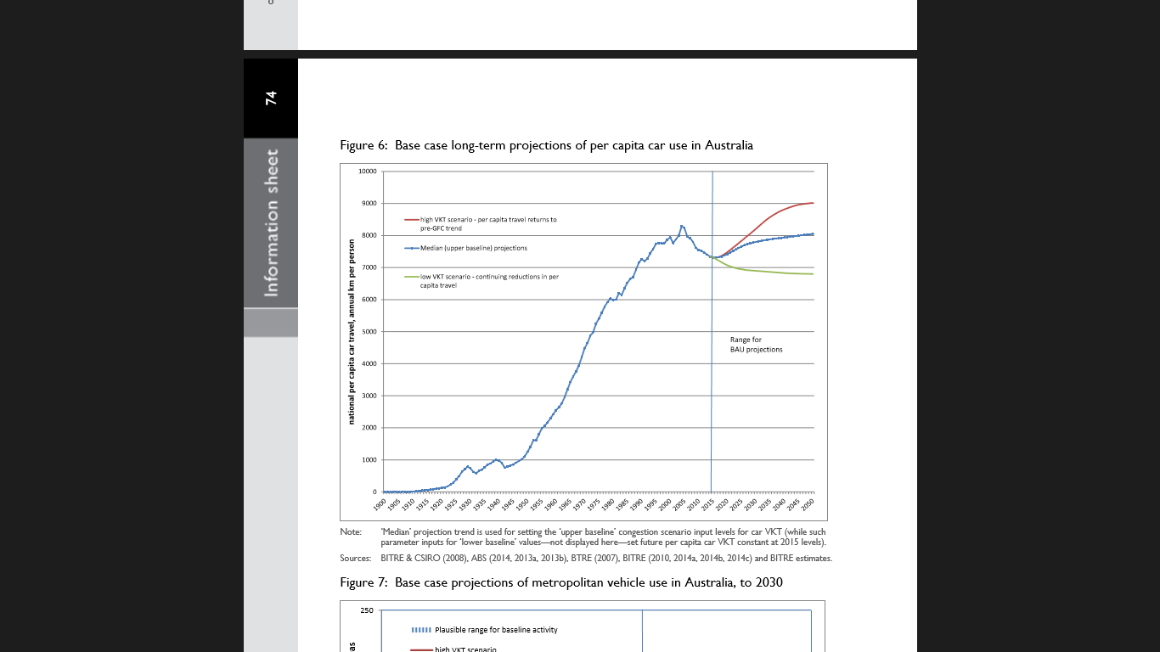
13. Figures 8 and 9 (below) show growth rates and a trend line fitted by excel spreadsheet function. The actual trend line 2000 to 2014 is downwards (figure 8). The trend line 2000 to 2030 (figure 9), including the projection period, is upwards. The difference occurs because the period 2015 to 2030 is higher on average than the preceding 15 years.

    **Figure 8: Bureau traffic growth actual trend 2000 to 2014**

    **Figure 9: Bureau traffic growth actual and projected trend 2000 to 2030**
14. See: [https://sourceable.net/congestion-on-roads-costing-australian-cities-billions/#](https://sourceable.net/congestion-on-roads-costing-australian-cities-billions/)
15. Westconnex reported blowout; <http://www.abc.net.au/news/2015-11-20/westconnex-construction-costs-blow-out-business-report/6958380>, note that the original cost estimate was around $10bn.

    Road maintenance deficit: a maintenance backlog in NSW of $5.3bn see: <http://www.smh.com.au/nsw/road-maintenance-backlog-grows-as-peak-hour-traffic-slows-20151122-gl4uhv.html>

    Auditors General reports: ‘wooden spoons’ for all <http://www.smh.com.au/business/comment-and-analysis/auditorgeneral-makes-it-official-east-west-link-was-a-debacle-top-to-bottom-20151209-gljdfi.html>, and for the Commonwealth <http://www.theguardian.com/australia-news/2015/dec/14/scathing-report-damns-abbotts-handling-of-east-west-link-funds>
16. Bureau of Infrastructure Transport and Regional Economics, *Infrastructure statistics yearbook,* various.

    From the 2014 yearbook

    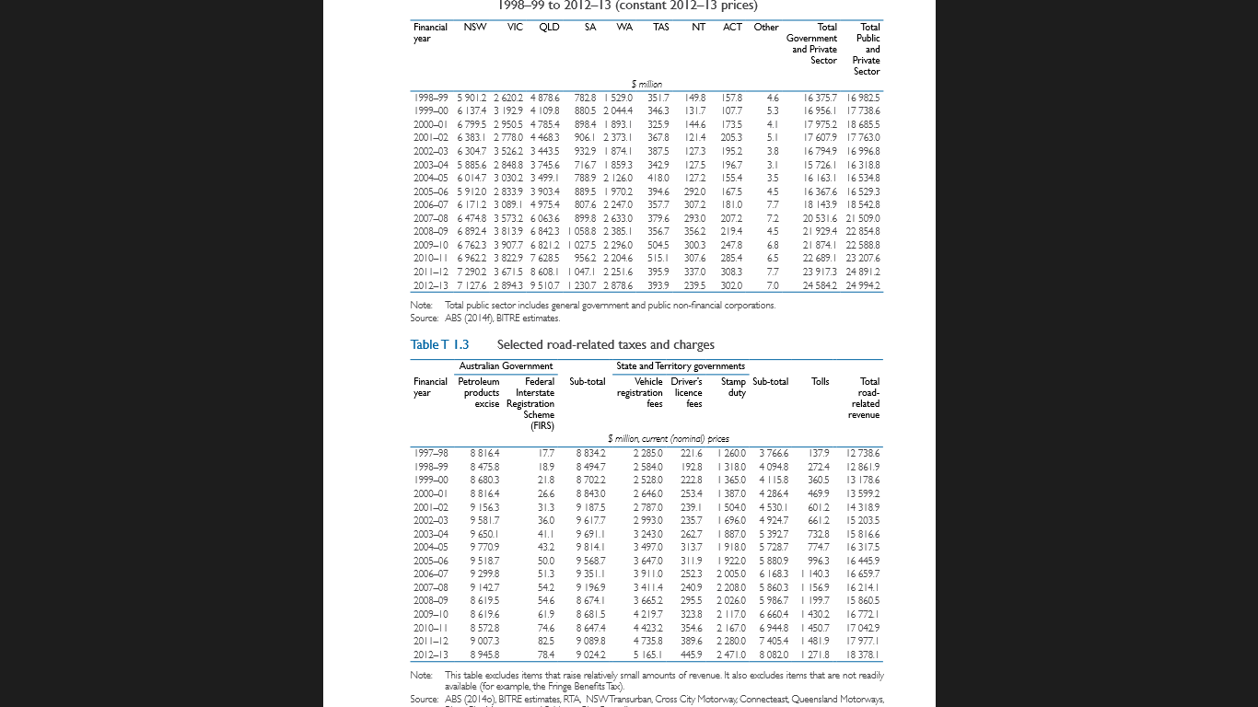

    From the 2015 yearbook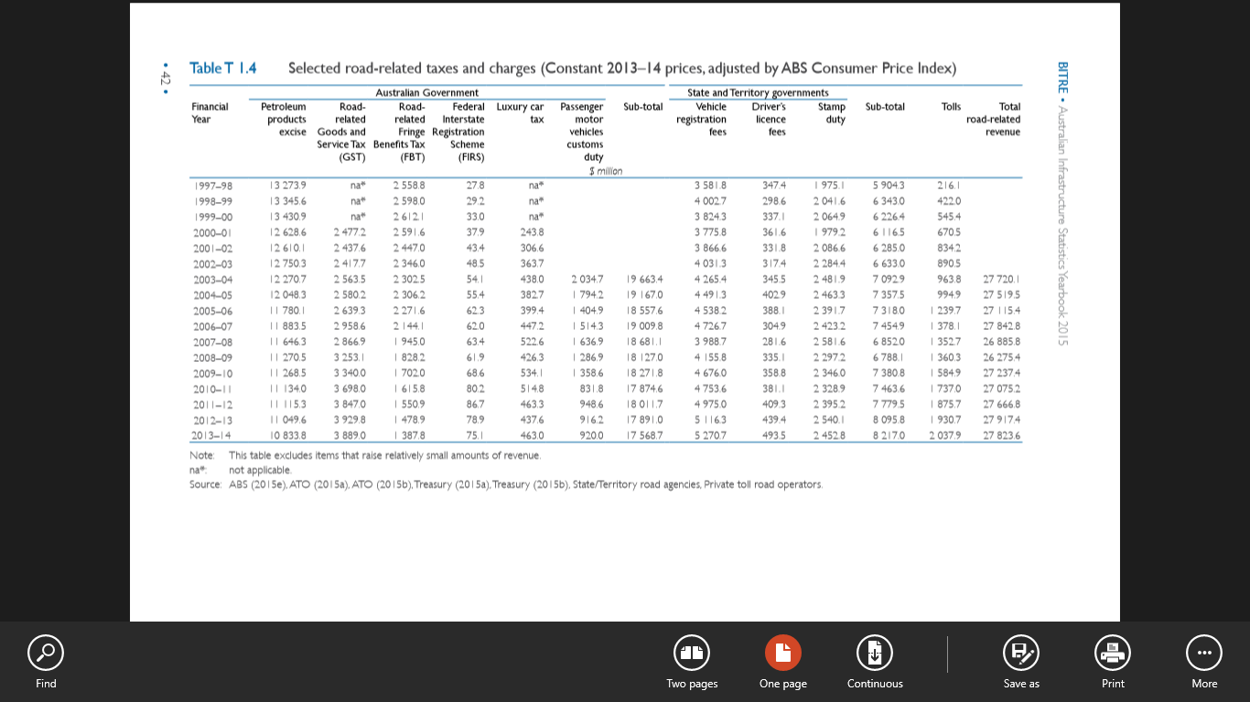

    Note that the 2015 yearbook refers to constant 2013-14 prices, so the figures need adjustment to derive nominal fiscal positions.

    Notes on the 2015 table follow:

    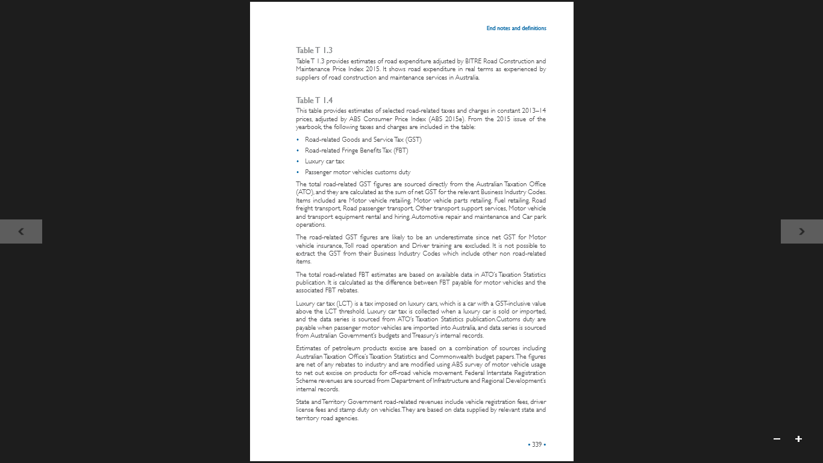

    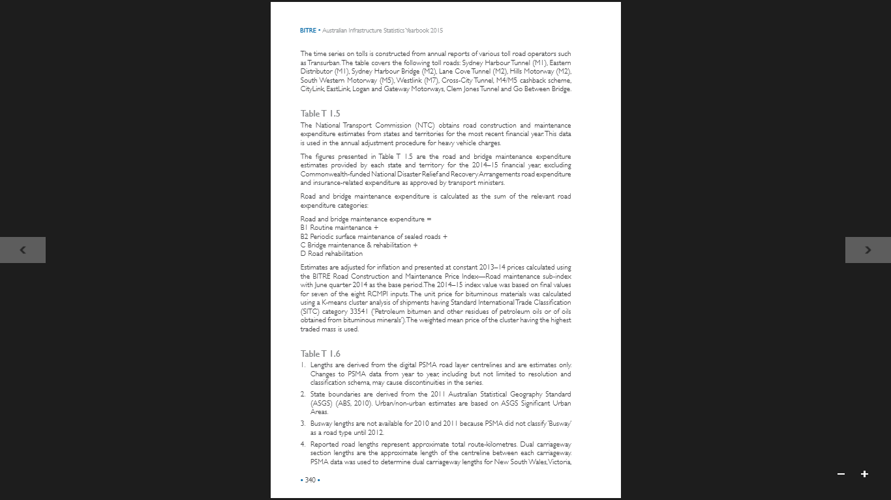

    Table 1 (below) shows the extent of the revision in excise.

    **Table 1: Infrastructure statistics yearbook 2014, 2015; Road related revenue – excise, $bn**

    |  |  |  |  |
    | --- | --- | --- | --- |
    | **Year** | **2014 yearbook** | **2015 yearbook (a)** | **change** |
    | 2003-04 | 9650 | 9378.0 | -272.0 |
    | 2004-05 | 9771 | 9474.7 | -296.3 |
    | 2005-06 | 9519 | 9833.1 | 314.1 |
    | 2006-07 | 9300 | 9932.8 | 632.8 |
    | 2007-08 | 9143 | 9940.3 | 797.3 |
    | 2008-09 | 8620 | 10169.2 | 1549.2 |
    | 2009-10 | 8620 | 10360.1 | 1740.1 |
    | 2010-11 | 8573 | 10580.5 | 2007.5 |
    | 2011-12 | 9007 | 10758.0 | 1751.0 |
    | 2012-13 | 8946 | 10834.0 | 1888.0 |
    |  |  |  |  |

    Converted to nominal $ by CPI

    |  |  |  |  |  |  |
    | --- | --- | --- | --- | --- | --- |
    |  |  |  |  |  |  |
    |  |  |  |  |  |  |

   
17. Trainline at https://bitre.gov.au/publications/publications.aspx?query=s:%22trainline%22&link-search=true