Maldon-Dombarton: the dog that didn’t bark

Proponent: A person who advocates a theory, proposal, or course of action.
Opponent: A person who disagrees with or resists a proposal or practice.

So far, the beagle has brought you all manner of infrastructure curios including some caused by curses and straw men taken seriously.
Here is another for the collection.
Infrastructure Australia’s core business is to assess projects put forward by proponents. In recent years, it published summary ‘evaluations’ of business cases deemed worthwhile.
It published one other evaluation; for completion of a Maldon-Dombarton rail line; roughly between Picton 80km south-west of Sydney and Wollongong/Port Kembla 80 km south of Sydney.
This is the sole case of Infrastructure Australia publishing a ‘not recommended’ evaluation.
That is, instead of ‘it is an initiative/has some potential’ or ‘may be worth doing later or if circumstances change’ or the (almost universal) refrain from comment at all, Maldon-Dombarton was given a definitive thumbs-down.
Why?
This brings to mind a Sherlock Holmes’ case; Sherlock concluded that a night-time theft was an inside job because the dog didn’t bark.
The idea behind Maldon-Dombarton is to provide another route for freight to/from Port Kembla. Map 1 shows the general layout.
Map 1: Port Kembla, Sydney etc
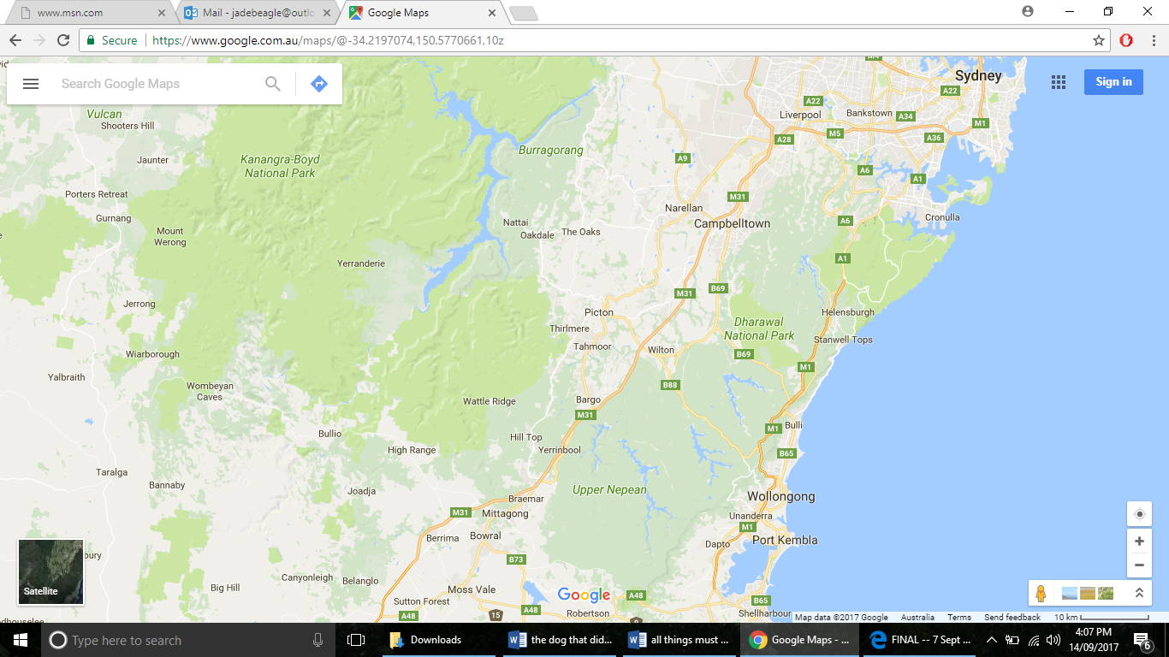
Port Kembla is already one of Australia’s most significant freight places e.g. steel, coal, large goods such as turbines. It is the principal point of car imports for Sydney, many of which are moved by road to storage near Campbelltown in south-western Sydney.
Its importance will increase very substantially in the medium term. It will be an ‘overflow’ for Port Botany (in Sydney, 70 km distant). Timing will depend on industrial and warehousing development in south western Sydney much of which is closer to Port Kembla than Botany.
At present, there are four freight routes to Kembla. These are inadequate for growth of the port:
- By road via Mt Ousley; large numbers of trucks already cross probably unsuitable gradients;
- By road via Macquarie Pass; unsuitable for most trucks;
- By rail through most of the Sydney metropolitan area and via the Illawarra line; which is already capacity constrained and has freight curfews;
- By rail from Moss Vale around 45km south of Picton; 110km from Sydney and which imposes high operational and cycle costs.
A Maldon-Dombarton line would shorten the distance between south west Sydney and Kembla by at least 65km. It was identified in the early 1980s. At that time, significant engineering works were undertaken in expectation of Kembla rapidly expanding as a coal port. In the event Newcastle expanded quickly and the works were suspended.
The strategic case for the line is clear. It is therefore a question of freight volumes; a ‘when’ not ‘if’ even if it is not economic today. Issues arising from Sydney Metro may make ‘when’ sooner rather than later.
Infrastructure Australia, however, concluded an economic case could not be made. Only citing claims from the proponent, the NSW Government, of a 0.9 benefit/cost it held the project would impose a net cost on the Australian economy.
It added there is sufficient capacity on the existing lines to meet medium term projections.
All well and good; it is not the only project where there is supposedly sufficient existing capacity and where benefits seem less than costs at present.
But it is the only project to achieve an explicit ‘not recommended’.
It is also the only case in which the ‘proponent’ virtually opposed the project.
Curious indeed Dr Watson!
The Commonwealth Department of Infrastructure also seems to have taken a dislike to the project. It ‘assessed’ the proposal several times concluding it is not worthwhile. However, before its views are taken too seriously readers should reflect on its ‘stitch up’ of high speed rail, inability to get to grips with western Sydney rail and leadership of policy failures such as non-recognition of gauge standardisation and mistakes about the nature of rail regulation.
Common sense stolen while the watchdog didn’t bark?
The beagle bays: another case deserving an independent open review.

J Austen
14 September 2017

https://en.oxforddictionaries.com/definition/opponent
http://infrastructureaustralia.gov.au/projects/files/Maldon-to-Dombarton-summary.pdf
https://brieflywriting.com/2012/07/25/the-dog-that-didnt-bark-what-we-can-learn-from-sir-arthur-conan-doyle-about-using-the-absence-of-expected-facts/
A short history of the proposal is at http://investment.infrastructure.gov.au/publications/reports/pdf/Maldon_Dombarton_Feasibility_Study_Full_Report_Final.pdf.
Distance compared with Moss Vale: Maldon-Dombarton = 35km; Moss Vale-Unanderra = 57km + Moss Vale-Picton =43 km. For Metro see the discussion of rail balancing at: http://www.thejadebeagle.com/sydney-2-exhibit-2-toucheth-not-the-monorail.html and http://www.thejadebeagle.com/toucheth-not-the-monorail-metro-summary-business-case.html
Compare http://investment.infrastructure.gov.au/publications/reports/pdf/maldon_dombarton_freight_rail_line_pre_feasibility_study_final_report.pdf with http://investment.infrastructure.gov.au/publications/reports/pdf/Maldon_Dombarton_Feasibility_Study_Full_Report_Final.pdf; the latter having a benefit/cost of 0.56 – lower than that presented by NSW. For high speed rail see: http://www.thejadebeagle.com/earth-to-canberra.html For western Sydney rail see: http://www.thejadebeagle.com/toucheth-not-the-monorail-western-sydney-rail.html For leading gross policy mistakes see: http://www.thejadebeagle.com/austral-obscura-2.html noting that the Commonwealth chairs the Ministerial Council and the officials’ advisory committee.

