# Sydney, metro again

In mid November 2016, the NSW government recently announced a west metro between Parramatta and Sydney’s CBD. Cost is at least $10bn and details are scant.[1]

While (belated) recognition of the need for more public transport between Parramatta and Sydney is welcome the announcement points to deeper problems.

A west metro idea was raised by Christie’s Inquiry. If Sydney needs any metro a line to Parramatta is the best candidate, although other public transport options such as higher speed rail, a new commuter line, light rail or bus rapid transit might be better and less costly.[2]

A west metro is unlikely to create the problems of the current metro projects. Indeed it could eventually undo some problems arising from the Northwest metro - eventually because it is unlikely to be operating until at least a decade from now.[3]

The latest announcement suggests the state government’s approach to railways, starting with the 2012 decision for a metro in suburbia, is at least back to front. A better sequence may have been west metro, harbour crossing etc.

It also suggests the approach is probably misconceived at least to the extent that a different sequence may have led to different metro routes and different transport projects; basic options not considered in the Sydney city/southwest metro summary business case.[4]

Christie’s Inquiry had a west metro continuing along the western side of the CBD to Barangaroo. It criticised a (then) state government proposal arguing that a metro through the CBD to Martin Place with a left hand turn to Barangaroo jeopardised other potential harbour crossings.[5]

In comparison, the planned City/southwest metro runs through the middle of the CBD before taking a left hand turn near Martin Place to Barangaroo. [6]

Among the implications of the current plan is that a west metro cannot use the (full) capacity of the planned harbour crossing; to some extent that crossing’s capacity is (at least partly) allocated to the southwest metro segment. In conjunction with any difficulties created for other harbour crossings this will reduce the effectiveness and/or increase the cost of any new Parramatta-Sydney rail line, whether metro or not.[7]

The suggestions about the government’s approach are reinforced by the announcement claiming a ‘need’ for a west metro; quite a jump from a need for better public transport. The clarity of need is contradicted by vagueness about critical aspects of any railway; route, stations and cost, and the leisurely timing of the project.[8]

There appears to be a metro bias.

Hence it is no surprise the announcement reiterated overblown rhetoric about metro capacity; supposedly 40,000 people each way per hour. Capacity is determined by what happens at the end of a line; as the CBD end of a west metro could now be problematic 40,000 seems very optimistic.

Another matter is that (other than for short passenger trips) the relevant capacity measure is seats per line. Theoretical metro capacity might stretch to 11,000-15,000 seats per hour; compared with commuter trains *proven* capacity of at least 18,000 seats which could be significantly increased. [9]

Associated commentary, such as metro trains travelling at up to 160kmh, is similarly suspect. Up to 30,000 people an hour standing on trains hurtling at that speed?[10]

The Commonwealth and NSW are jointly studying western Sydney rail needs; a report is due in mid-2017. Public comments on a (deficient) discussion paper were sought by the end of last month. The state government could not have adequately considered comments before it made its west metro announcement; an announcement that pre-empts the study results.

A previous article argued that if the real questions about Sydney rail planning were not soon publicly answered the Commonwealth Parliament should get involved. Far from giving answers the latest state material raises more questions. A Commonwealth Parliamentary inquiry is needed.

J Austen

30 November 2016

**Notes**

1. Recent article: *Toucheth not the monorail: western Sydney rail* at thejadebeagle.com.

   Announcements: <https://www.nsw.gov.au/media-releases-premier/sydney-metro-west-new-railway-more-trains-western-sydney>, <http://www.transport.nsw.gov.au/sites/default/files/b2b/projects/sydney-metro-west-project-overview-nov-2016.pdf>
2. *Independent Public Inquiry into a Long Term Transport Plan for Sydney, Final Report,* May 2010 (Christie Inquiry) at: <http://www.catalyst.com.au/>.
3. One of the problems of the Northwest metro is it creating a need to divert some inbound commuter and intercity trains to Strathfield (rather than Chatswood), increasing density in the western line and making CBD and harbour bridge commuter train balancing more difficult. The service quality of faster commuter trains may be further affected because of the urban growth in the North-Strathfield/Concord area; faster trains may need to slow behind all-stations trains or undertake more stops themselves. A west metro might be able to serve this area and thus mitigate the slowing effect – this is yet to be demonstrated.

  
4. The summary business case, released in mid-October 2016, did not consider commuter rail improvements such as another harbour crossing.

   While it claims a western CBD alignment was considered, no details are provided as to why this option was assessed as failing on one criterion which prima facie it would pass (‘improve the efficacy and cost effectiveness of the public transport system’); at least several of the claimed assessments deserve detailed explanation (business case at p47).

   Also notable is the summary business case failed to identify criteria such as suggested by Christie’s Inquiry (for example along the lines of ‘enable future development of public transport’).

   Nor did it consider a west metro option, which may have made a western CBD alignment preferred as identified in Christie’s Inquiry.

   This will be the subject of a later article. See: <http://www.sydneymetro.info/sites/default/files/Sydney%20Metro%20CSW%20Business%20Case%20Summary.pdf>
5. The Christie Inquiry atp.199 and 200 the Inquiry referred to the then (2008-10) government’s proposal for a CBD metro:

   *‘The proposed “CBD Metro” route would have jeopardised, perhaps fatally, future heavy rail capacity expansion and congestion-relief options within the CBD and across the harbour, thereby effectively dooming almost all of the CityRail network never to be able to cater for the inevitable and rapid growth in patronage demand in the future’*.

   The author’s understanding of the criticised route is:

   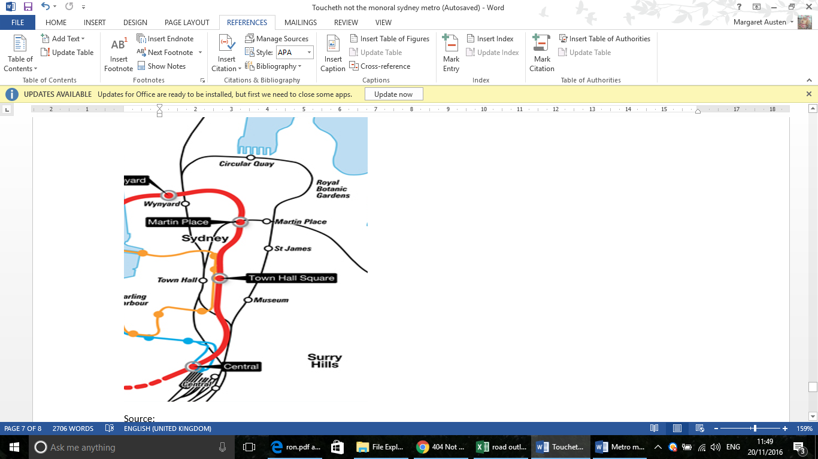

   http://web.archive.org/web/20091004023409/http://www.sydneymetro.nsw.gov.au/mediagallery/photo/sydney_metro_route_map/
6. The proposed route of the Sydney city/southwest metro is shown in the Sydney Metro City and Southwest summary business case thus:

   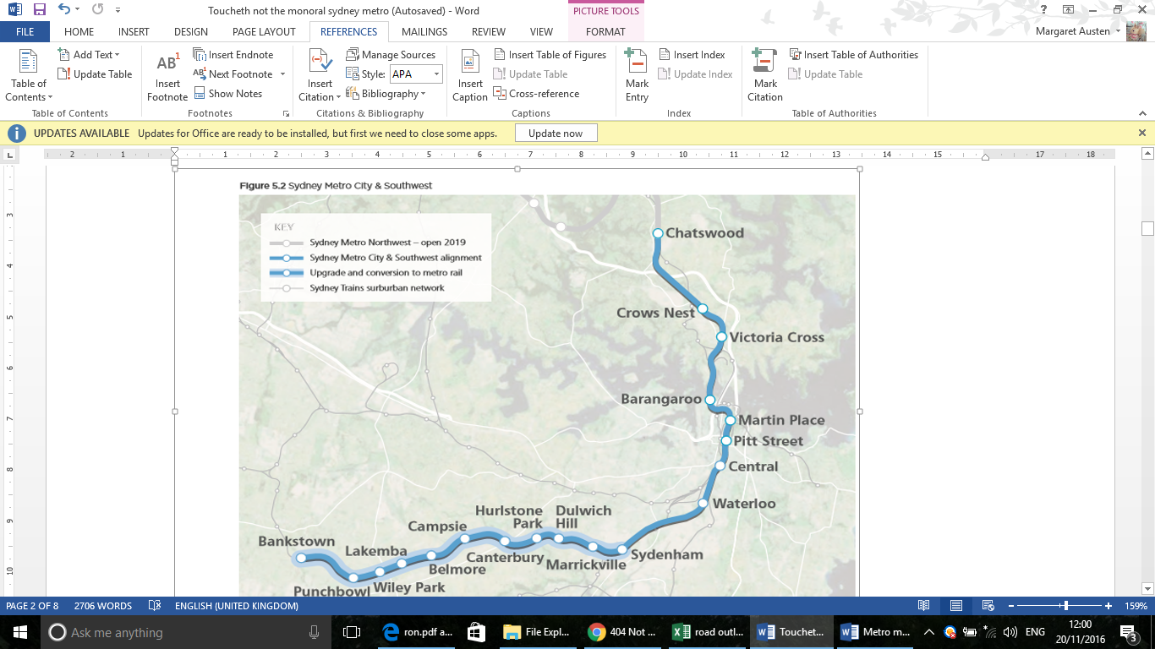
7. If, for example, metro capacity is 30 trains per line per hour then 30 trains from the western metro and 30 trains from the southwest metro cannot both use a single harbour line in one hour. The result: trains on either or both metros need to be ‘turned back’ before a harbour crossing; or an extension of the west metro is needed possibly towards the eastern suburbs, meaning that some metro passengers for the CBD will need to change trains; or effective capacity on the combined southwest and west metros is reduced to 30 trains run on both eg. only 15 trains per hour on each.
8. The announcement included a map (below) which might be compared with maps in the earlier references. Note there is no information about a route in the CBD:

   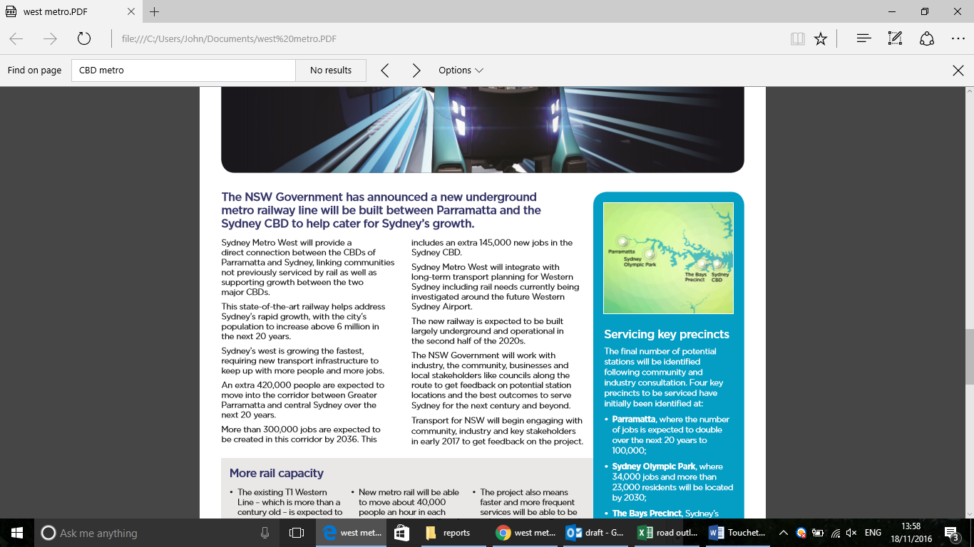
9. Addressed in *Toucheth not the monorail: western Sydney rail*. To reiterate, the claim of 40,000 passengers per hour translates (at 30 trains per hour) into 1333 passengers per train. Northwest metro trains are reportedly configured in 6 car sets with 378 people. If this were arithmetically expanded, an 8 car metro set would have 504 seats; if a metro line could operate 30 such trains per hour (which would be more demanding than operating the same number of 6 car sets) theoretical maximum capacity of a line is between 11,340 and 15120 seats.

  
10. See: http://www.abc.net.au/news/2016-11-14/sydney-metro-west-train-linking-sydney-cbd-and-parramatta/8022564