Comment on Pearls and Irritations Saturdays Good reading and listening for the weekend 13 February 2021 (with notes)

Text

‘The pandemic’s progress
Australia – hotel quarantine stuffed up again
To quote from the Constitution:
Part V – Powers of the Parliament 51. Legislative powers of the Parliament
The Parliament shall, subject to this Constitution, have power to make laws for the peace, order, and good government of the Commonwealth with respect to:
[…]
(ix) quarantine;

By now premiers must realise that Morrison, the master in marketing, sold the states a pup when he handed over quarantine to the states while the Commonwealth looked after transfer payments. The Commonwealth’s higher rate of unemployment benefits and youth allowances ends next month, but infected travellers will be entering the country in increasing numbers for years to come.

As Adrian Easterman of the University of South Australia says (and as do many others), it’s time to move hotel quarantine out of cities, and the Commonwealth needs to shoulder its constitutional responsibility. (The Conversation).

It is hard to imagine the injustice people must feel when they have spent difficult months in England or some other highly-infected country successfully guarding against the virus, only to be exposed to it because of cobbled-together quarantine arrangements on their return home. They have every right to be angry at the Commonwealth which has taken all credit for the states’ hard work in suppressing the virus while neglecting its responsibilities in quarantine and aged care.
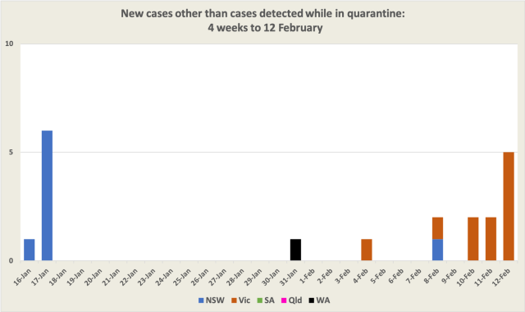
Why outbreaks matter
One of the commentators last week pointed out that even though the highly infection UK mutant had escaped from quarantine there wasn’t evidence that it had spread. Yet we had borne the costs of hundreds of thousands of tests and partial lockdowns. Were such reactions necessary?

That’s a valid point, but we should be wary of the “just one case” idea. As a reminder, below is a chart of what happened in Victoria in June last year – note the logarithmic scale. On June 6 there were no recorded cases, on June 7 there was one case. The rest is a story of exponential growth, until it started to be checked about three weeks later (where the black line dips below the red trend line), at massive cost to the state and the nation. With at least 13 cases in the current outbreak Victoria is already a fair way along that line once again.

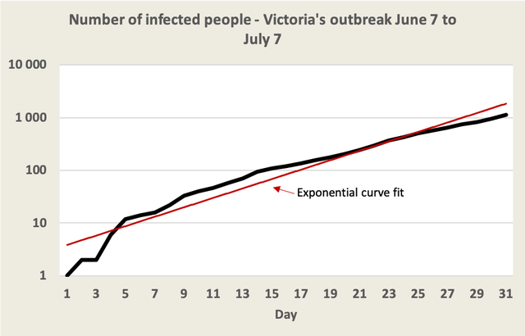

The Morrison Government’s variation on the “just one case” argument is to assert that out of 250 000 people who have passed through hotel quarantine, there has been only “a handful” of cases that made it into the community. That’s its defence of hotel quarantine backed by its reluctance to deal with the strong evidence that the virus spreads through aerosols, because hotels cannot protect against aerosol transmission. If it admits that hotel quarantine cannot work, the Commonwealth would have to invest in more well-ventilated facilities such as Howard Springs.

The line that aerosols aren’t responsible for virus transmission is becoming increasingly difficult for Commonwealth officials to defend, leading to community suspicion at a time when community trust is most needed.’

Comment
As one who asked about the (lack of evidence of) spread of the highly/hyper infectious Covid mutant in Qld and WA, I am not sure this post understands the point.

Some facts at present (13 February):
- Brisbane and Perth etc. were locked-down for a combined total of 8 days when there were a total of 2-3 cases outside quarantine. At least 30 public locations were visited by the cases over 10 days before the lockdowns. 380,000 tests since disclosed one further case outside quarantine. It is now over a month since Qld’s last case, two weeks WA. No evidence of a related case in other States;
- Qld and WA brag about Covid ‘performance’. Just prior to its ‘outbreak’, Qld publicised being Covid free for 100 days and urged its residents to return home;
- the lockdowns were supposed to be decided by officials alone. Ministers/ Premiers were not supposed to decide or influence them.

These circumstances warrant formal, public examination. Explanations need to be better than: the lockdowns worked (retrospectively mainly); infected individuals weren’t infective with the highly infectious mutant. In the absence of proper explanations, credibility will remain damaged.

Talk about greater in-hotel transmissibility, and ‘aerosol’, is a distraction. It makes things worse: why was this not a problem in shopping centres etc. the cases visited?

Simple comparisons don’t cut it. True there was acceleration in infection in Melbourne mid last year. Acceleration is also seen in figures for the simultaneous Sydney outbreaks in mid-December. But neither mentioned highly/hyper infectious etc. They make a look at the Qld, WA scoreboards even more troubling.

Perhaps some cases will emerge in WA, but that is also speculation.

Onto Victoria. An official made the decision to lockdown the State.

Reports about Cabinet meeting raises the type of issues which troubled the Court in Loeilo’s case, but are a lot harder to sidestep here.

That case implied lockdown decisions should be overtly made by Governments, not officials, and should take into account more than Covid. I agree.

Let’s hope the trajectory in Melbourne is like Sydney – where daily numbers fell quickly. To low single digits at New Year - giving the lie to claims NSW had ‘lost control’, expectations of several thousand cases, and several hundred undetected cases.

The point is: if widespread vaccination is the ‘hope’:
- Community cooperation is important. That can depend on trust – how long can that last with the above? Another, temporary, prop is to create boogeymen outside the local community (us v. them) – as seems to be how some Govts and commentators frame NSW. Destructive and dangerous.
- Covid cases may arise after widespread vaccination, for years. Will lockdowns over single (suspected) cases continue?
- If so, some Governments have locked their States and Australia into an untenable position.

Last things: quarantine?:
Sold a pup? More like: enthusiastically sought a dog to show off – see the Vic. hotels report.
Outside cities? Perhaps. Politically nice as it might help to avoid questions like those above. But at least one of the Sydney outbreaks reputedly started with a person engaged to drive international arrivals to the quarantine hotels.
Commonwealth responsibility? Yes. It does not mean conduct of the function but it does mean warranting to the community the function is competently conducted.

Again: donut not hole.

Happy to be corrected on any of the above.

Best wishes

https://johnmenadue.com/saturdays-good-reading-and-listening-for-the-weekend-101/
Qld: by Chief Health Officer https://www.health.qld.gov.au/system-governance/legislation/cho-public-health-directions-under-expanded-public-health-act-powers/revoked/restrictions-impacted-areas. Note s.362FA of relevant Act says the Chief Health Officer’s directions power is non-delegable; the direction was posted (minutes) after it took effect. WA: by Police Commissioner/State Emergency Coordinator https://www.wa.gov.au/sites/default/files/2021-02/Stay%20at%20Home%20and%20Closure%20%28Perth%2C%20Peel%20and%20the%20South%20West%20Regions%29%20Directions%20%28No2%29%20-%201%20February%202021.pdf
https://theconversation.com/perths-5-day-circuit-breaker-lockdown-isnt-an-overreaction-to-a-single-case-its-basic-common-sense-154348
https://data.nsw.gov.au/data/dataset/nsw-covid-19-cases-by-location-and-likely-source-of-infection/resource/2776dbb8-f807-4fb2-b1ed-184a6fc2c8aa
https://www.dhhs.vic.gov.au/sites/default/files/documents/202102/Stay%20Safe%20Directions%20%28Victoria%29%20%28No%2014%29%20-%2012%20February%202021_1.pdf
Report that Cabinet met to consider a lockdown: https://www.9news.com.au/national/emergency-meeting-coronavirus-victoria-snap-lockdown-holiday-inn-outbreak/4a867858-775a-423a-8b50-0c945e469b8c One part of the Loeilo case turned on whether the Premier or unknown party effectively made the decision to extend the Melbourne curfew – if so the extension would have been invalid because only an official could make that decision:. https://www.supremecourt.vic.gov.au/sites/default/files/2020-11/Loielo%20v%20Giles%20%5B2020%5D%20VSC%20722_0.pdf
‘Parliament may wish to reconsider who should exercise these emergency powers and whether their exercise should be required to take into account matters such as the social and economic consequences of their exercise.’ Note 6, above.
https://johnmenadue.com/tony-smith-how-new-south-wales-lost-control-of-the-virus/ https://www.msn.com/en-au/news/australia/greg-hunt-slams-doctors-who-were-wrong-about-covid-19/ar-BB1cHMIT?ocid=mailsignout&fbclid=IwAR2KhevDg-KnH5JdH7fM78093PvpF1GPtP77tpqKsWM9b0eKNnHQQu3_Uj4
https://johnmenadue.com/we-have-the-tools-to-help-control-the-pandemic-we-have-to-use-them/
‘As of 27 March 2020, the Australian Health Protection Principal Committee (AHPPC) had only recommended to the National Cabinet enforced quarantine for ‘high-risk’ cases. Nevertheless, both the National Cabinet and, in turn, the Victorian Premier took the decision to direct the mandatory detention of all international arrivals into designated facilities which, in Victoria, were hotels. Both the CHO and the DCHO supported the decision’… ‘The Premier was aware there was no pre-existing plan for large scale quarantine in Victoria and there had been no discussion in the State Cabinet about the National Cabinet decision. However, he considered the Program feasible to achieve based on his knowledge of the availability of hotel rooms and the dedicated team of people at the operational level able to rise to this challenge’. https://www.quarantineinquiry.vic.gov.au/volume-i
https://www.reuters.com/article/health-coronavirus-australia-outbreak-ex-idUSKBN28V0F7 https://www.abc.net.au/news/2021-01-03/nsw-records-eight-new-local-cases-of-covid-19/13028376

